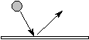

Signs:
 | Player |  | opponent |  | Player who passes |  | Trainer
 | Cone |  | goal |  | ball |  | balls
 | goalscoring-  triangle |  | either/  or |  | if/then |  | stick
 | Way of ball |  | scoop |  | goalscoring |  | conducting
 | Way of player |  | elemination |  | channeling
I. Receiving at the boards
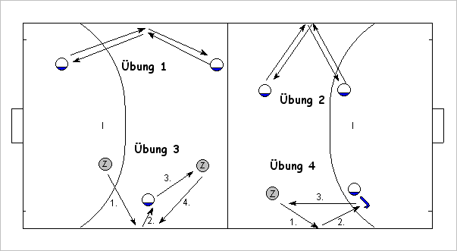
Drill 1: easy passing with the boards in a obtuse-angle
Drill 2: easy passing with the boards in a obtuse-angle
Drill 3: Passing players are in the back of receiving player, pass with the boards
Drill 4: Receiving with small backhand after pass with the boards
II. Receiving at the boards in movement
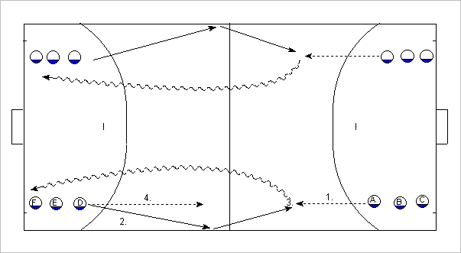
Drill 1: Player A moves to the pass (with the boards) of player D and receives the ball. After that he dribbles to player D.

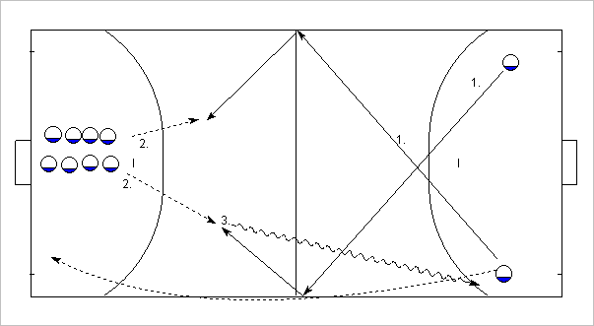
Drill 2: PLayers run to the ball and receive in movement.

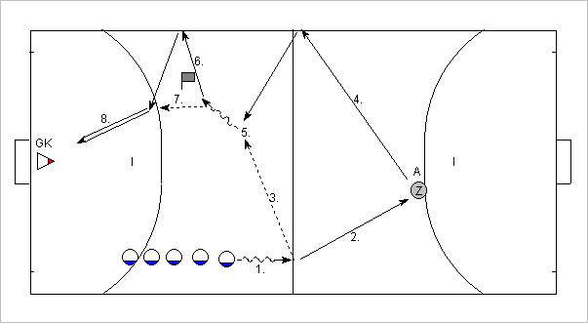
Drill 4: PLayers dribble the ball and pass to Z, after that they run to the right board. Player Zer A passes with the right board. After receiving the ball you play a wall-pass with the board and score
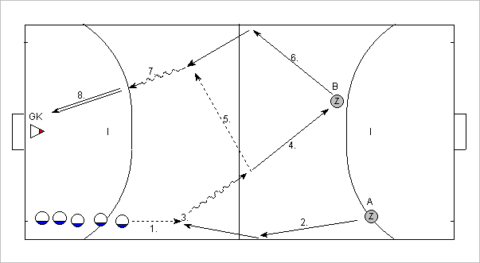
Drill 3: Player Z passes with the left board. Players receive in movement and dribble to the mid. They play to the next player Z and receive the ball at the right board, enter the D and score

III. Elemination with the boards
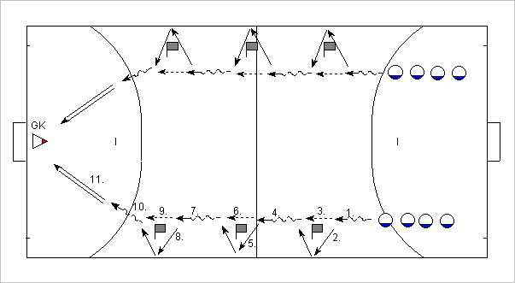
Preparing drill 1: Players conduct the ball and play wall-passes aroung the cone (timing!)
Hinweis: at the right board you have to play with forehand. You have to conduct the ball behind you
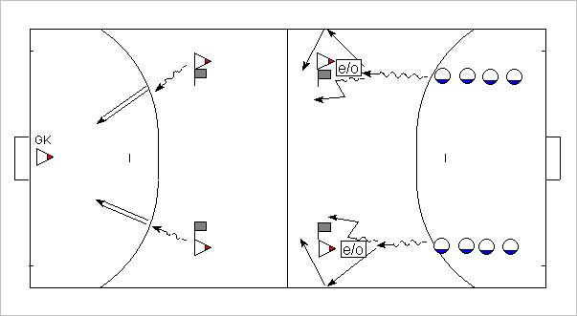
Vordrill 2: players eleminate opponents (half active) either with or without the boards
Opponents have to touch always the cone by one foot
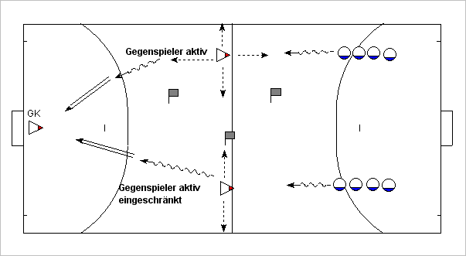
Drill 1: Eleminaion with or without boards against full active opponent
Variation: opponent can move only on a line or in a square

